

Google I/O 2015 Extended Madurai

Sponsorship package

………………………………….

May 28th and 29th 2015, @Madurai

Special partner

C:\Users\senthilm\Pictures\Logo\metoomentor\metoomento.png

**A word about Google I/O**

*“Google I/O is for developers—the creative coders who are building what's next. Together we'll explore the latest in tech, mobile & beyond.”*

Google I/O is two days of inspirational talks, hands-on learning, and a chance to hear more about Google's latest developer products. The event takes place every year in San Francisco and features highly technical, in-depth sessions focused on building web, mobile, and enterprise applications with Google and open web technologies such as Android, Chrome, Chrome OS, Google APIs, Google WebToolkit, App Engine, and more.

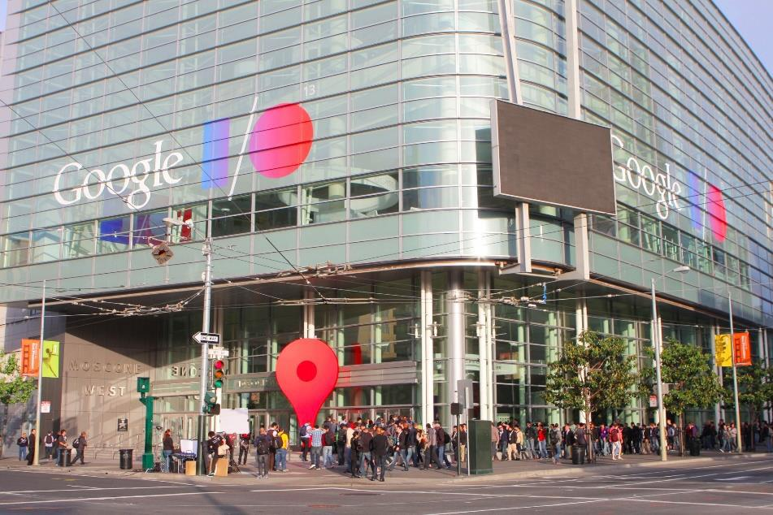

For more information about Google I/O, please visit [https://events.google.com/io20](https://events.google.com/io2015/) [15/](https://events.google.com/io2015/)

**What are I/O Extended events?**

Google I/O Extended events are focused on bringing the local developer community together to experience the keynote and other main Google I/O sessions together, in real-time. They also offer unique activities targeted to developers, such as hackathons and codelabs.

Google I/O 2015 Extended Madurai in a nutshell:

* Live streams and replays of the conferences delivered at Google I/O in San Francisco
* Local animations such as technical workshops and codelabs
* Networking events – two major networking events are to be organized on site
* Exhibition area for startups

**Date & location**

*For the* ***first time****, Google I/O is to land in Madurai on May 28th and May 29th.*

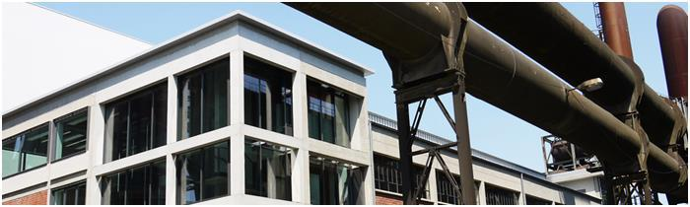

This **first edition** of Google I/O Extended Madurai will be held at **Madurai**, in on **May** **28th and May 29th**.

**Why sponsoring Google I/O 2015 Extended Madurai?**

For the first edition, around 200 people from the developers and tech community are expected.

Advantages of sponsoring Google I/O 2015 Extended Madurai:

* Give visibility to your organization and associate your brand with a major event around developer technologies and Google innovations
* Promote your expertise and solutions to a targeted audience
* Network and meet with potential partners or customers
* Support the local tech scene and open innovation
* Connect with technical experts
* Acquire leading position by being part of the first edition in Madurai

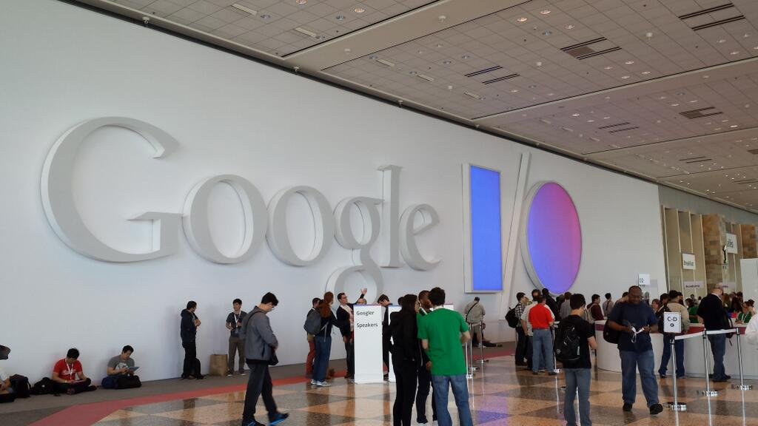

**Sponsorship package**

Google I/O 2015 Extended Madurai offers three sponsoring levels, plus one closing Snacks sponsorship:

* Hosting partner sponsorship - **only two Hosting partner sponsorships are available**
* FeedFood sponsorship **– only three sponsorships are available [Lunch, dinner, Snacks]**
* Gold – Rs.15,000/- - **only one Gold sponsorship is available**
* Silver – Rs.10,000/- - **only two Silver sponsorships are available**
* Bronze – Rs.5000 - **only five Bronze sponsorships are available**

**Hosting partner sponsorship Benefits**

|  |  |  |  |  |
| --- | --- | --- | --- | --- |
|  | **BEFORE THE EVENT** | **HOSTING SPONSORSHIP (May 29th)** |  |  |
|  | Your organization logo on every |  |  |  |
|  | communication supports promoting |  |  |  |
|  | Google I/O 2015 Extended |  |  |  |
|  |  |  |  |
|  | Madurai |  |  |  |
|  | Company mention on press release |  |  |  |
|  | Description of your College/company on the |  |  |  |
|  | Google event page and Facebook | **Up to 250 words** |  |  |
|  | event page |  |  |  |
|  | **DURING THE EVENT** | **HOSTING SPONSORSHIP (May 29th)** |  |  |
|  | 10-minute speaking slot session to |  |  |  |
|  | Tell about your college and infrastructure for student to get more Admission for 2015 batch |  |  |  |
|  | Roll up in the Snacks area | **2** |  |  |
|  | Your logo on the event agenda |  |  |  |
|  | Brochure on the Snacks tables |  |  |  |
|  | Goodies on the Snacks tables |  |  |  |
|  | Free tickets | **4** |  |  |
|  | **AFTER THE EVENT** | **HOSTING SPONSORSHIP (May 29th)** |  |  |
|  | Your organization logo in the emailing |  |  |  |
|  |  |  |  |
|  | sent to all attendees |  |  |  |
|  |  |  |  |
|  | Company mention on press release |  |  |  |
|  |  |  |  |  |
|  | **Requirement for hosting** | **Place which can accommodate 200+ Students and Developers, Mic, Speakers, Good Internet connectivity for one Main laptop connected to the projector.** |  |  |
|  |  |  |  |  |

**FeedFood sponsorship Benefits**

Please join us to feed food for the participants during the event of May 29th Google I/O 2015 Extended Madurai.

**Three one** FeedFood Sponsorship available you can sponsorship Lunch, Snacks sponsorship on May 29th. Please find below what you can benefitfor.

|  |  |  |  |  |
| --- | --- | --- | --- | --- |
|  | **BEFORE THE EVENT** | **FEEDFOOD SPONSORSHIP (May 29th)** |  |  |
|  | Your organization logo on every |  |  |  |
|  | communication supports promoting |  |  |  |
|  | Google I/O 2015 Extended |  |  |  |
|  |  |  |  |
|  | Madurai |  |  |  |
|  | Company mention on press release |  |  |  |
|  | Description of your company on the |  |  |  |
|  | Google event page and Facebook | **Up to 250 words** |  |  |
|  | event page |  |  |  |
|  | **DURING THE EVENT** | **FEEDFOOD SPONSORSHIP (May 29th)** |  |  |
|  | Roll up in the Snacks area | **2** |  |  |
|  | Your logo on the event agenda |  |  |  |
|  | Brochure on the Snacks tables |  |  |  |
|  | Goodies on the Snacks tables |  |  |  |
|  | Free tickets | **4** |  |  |
|  | **AFTER THE EVENT** | **FEEDFOOD SPONSORSHIP (May 29th)** |  |  |
|  | Your organization logo in the emailing |  |  |  |
|  |  |  |  |
|  | sent to all attendees |  |  |  |
|  |  |  |  |
|  | Company mention on press release |  |  |  |
|  |  |  |  |  |
|  | **PRICE** | **Lunch/Snacks expenses** |  |  |
|  |  |  |  |  |



**Main sponsorship Benefits**

|  |  |  |  |  |  |  |  |  |  |  |  |  |
| --- | --- | --- | --- | --- | --- | --- | --- | --- | --- | --- | --- | --- |
|  | **BEFORE THE EVENT** |  |  | **GOLD** |  |  | **SILVER** |  | **BRONZE** |  |  |  |
|  | Your organization logo on every |  |  |  |  |  |  |  |  |  |  |  |
|  | communication supports promoting |  |  |  |  |  |  |  |  |  |  |  |
|  |  |  |  |  |  |  |  |  |  |  |  |
|  | Google I/O 2015 Extended |  |  |  |  |  |  |  |  |  |  |  |
|  |  |  |  |  |  |  |  |  |  |  |  |
|  | Madurai |  |  |  |  |  |  |  |  |  |  |  |
|  | Your organization logo on top of other |  |  |  |  |  |  |  |  |  |  |  |
|  | logos on every communication |  |  |  |  |  | **-** |  | **-** |  |  |  |
|  |  |  |  |  |  |  |  |  |  |
|  | supports promoting Google I/O 2015 |  |  |  |  |  |  |  |  |  |
|  |  |  |  |  |  |  |  |  |  |  |  |
|  | Extended Madurai |  |  |  |  |  |  |  |  |  |  |  |
|  | Company mention on press release |  |  |  |  |  |  |  |  |  |  |  |
|  |  |  |  |  |  |  |  |  |  |  |  |  |
|  | Description of your company on the |  |  | **Up to 350** |  |  | **Up to 250** |  |  |  |  |  |
|  | Google event page and Facebook |  |  |  |  |  | **Up to 100 words** |  |  |  |
|  |  |  | **words** |  |  | **words** |  |  |  |  |
|  | event page |  |  |  |  |  |  |  |  |  |
|  |  |  |  |  |  |  |  |  |  |  |  |
|  | **DURING THE EVENT** |  |  | **GOLD** |  |  | **SILVER** |  | **BRONZE** |  |  |  |
|  | 10-minute speaking session during the |  |  |  |  |  | **-** |  | **-** |  |  |  |
|  |  |  |  |  |  |  |  |  |  |
|  | introduction speech (May 28th) |  |  |  |  |  |  |  |  |  |
|  |  |  |  |  |  |  |  |  |  |  |  |
|  | Roll up entrance |  |  | **2** |  |  | **1** |  | **-** |  |  |  |
|  | Roll up main conference room |  |  | **1** |  |  | **1** |  | **-** |  |  |  |
|  | Your logo on the event agenda |  |  |  |  |  |  |  |  |  |  |  |
|  | Your brochure given to all attendees |  |  |  |  |  |  |  |  |  |  |  |
|  |  |  |  |  |  |  |  |  |  |  |  |
|  | at the welcome desk |  |  |  |  |  |  |  |  |  |  |  |
|  |  |  |  |  |  |  |  |  |  |  |  |
|  | Goodies on welcome desk |  |  |  |  |  |  |  | **-** |  |  |  |
|  | Goodies on seats during the |  |  |  |  |  | **-** |  | **-** |  |  |  |
|  |  |  |  |  |  |  |  |  |  |
|  | introduction speech |  |  |  |  |  |  |  |  |  |
|  |  |  |  |  |  |  |  |  |  |  |  |
|  | Free tickets |  |  | **5** |  |  | **4** |  | **2** |  |  |  |
|  | **AFTER THE EVENT** |  |  | **GOLD** |  |  | **SILVER** |  | **BRONZE** |  |  |  |
|  | Your organization logo in the emailing |  |  |  |  |  |  |  |  |  |  |  |
|  |  |  |  |  |  |  |  |  |  |  |  |
|  | sent to all attendees |  |  |  |  |  |  |  |  |  |  |  |
|  |  |  |  |  |  |  |  |  |  |  |  |
|  | Your organization logo on top of other |  |  |  |  |  |  |  |  |  |  |  |
|  | logos in the emailing sent to all |  |  |  |  |  | **-** |  | **-** |  |  |  |
|  |  |  |  |  |  |  |  |  |  |
|  | attendees |  |  |  |  |  |  |  |  |  |  |  |
|  | Company mention on press release |  |  |  |  |  |  |  |  |  |  |  |
|  | **PRICE** |  |  | **15000** |  |  | **10000** |  | **5000** |  |  |  |
|  |  |  |  |  |  |  |  |  |  |  |  |  |



**Terms and conditions**

Sponsorship takes effect after the quote is accepted, signed and sent back to the Google I/O 2015 Madurai organizers.

Payment has to be made at the latest 5 days before the event.

**CONTACT**

If you would like to sponsor Google I/O 2015 Extended Madurai, please contact:

Senthilkumar M

+91-8095207092

sentenwin@gmail.com

***Want to be kept up to date about the event?***

Join the Google event page of Google I/O 2015 Extended Madurai and be part of the community!

Like our Facebook page and follow us on Twitter. You can use the hashtag **#io15extendedMadurai** to communicate about the event.